IREVOLUTION: A DATA-DRIVEN EXPLORATION OF APPLE'S IPHONE IMPACT IN INDIA

Introduction:

The world has changed as a consequence of the increasing use of smart phones, which have improved communication, connected people, and revolutionized many different businesses. With its main product, the iPhone, capturing markets around the world, Apple Inc. has emerged as a prominent player among the top Smartphone makers. India, one of the economies with the greatest economic growth, has seen a tremendous increase in Smartphone usage.

In order to shed light on important factors like market penetration, customer preferences, economic ramifications, and societal changes, this research report will perform a data-driven investigation of the impact of the iPhone in India. This study will offer invaluable insights into the transformative impact of the iPhone on India's technological landscape and the lives of its consumers by using advanced data analytics techniques and analyzing large datasets.

OverView
Apple has a special chance to increase its market share and develop a significant presence in India thanks to the country's large population and rising Smartphone adoption. Each new iPhone model unveiling generates excitement and anticipation among Indian buyers. By utilizing the plethora of information. Already accessible, this research aims to go beyond conjecture and anecdotal evidence in order to develop a thorough knowledge of the effects of the iPhone.
The international trip is the strongest sign yet that India has become a huge strategic focus for Apple as supply chains move away from China and its Smartphone market is increasingly saturated with iPhone owners.
India could echo the role China has played in Apple’s business for the last 15 years: A massive market with an expanding middle class to power sales growth, and potentially a home base for the production of millions of Apple devices.
Analysts say that India’s large population and maturing economy is ideally situated for Apple to make inroads by increasing marketing efforts and offering retail in the country. At the same time, India’s government is eager to work closely with Apple to make it possible to manufacture in the country.

Dataset Connect:
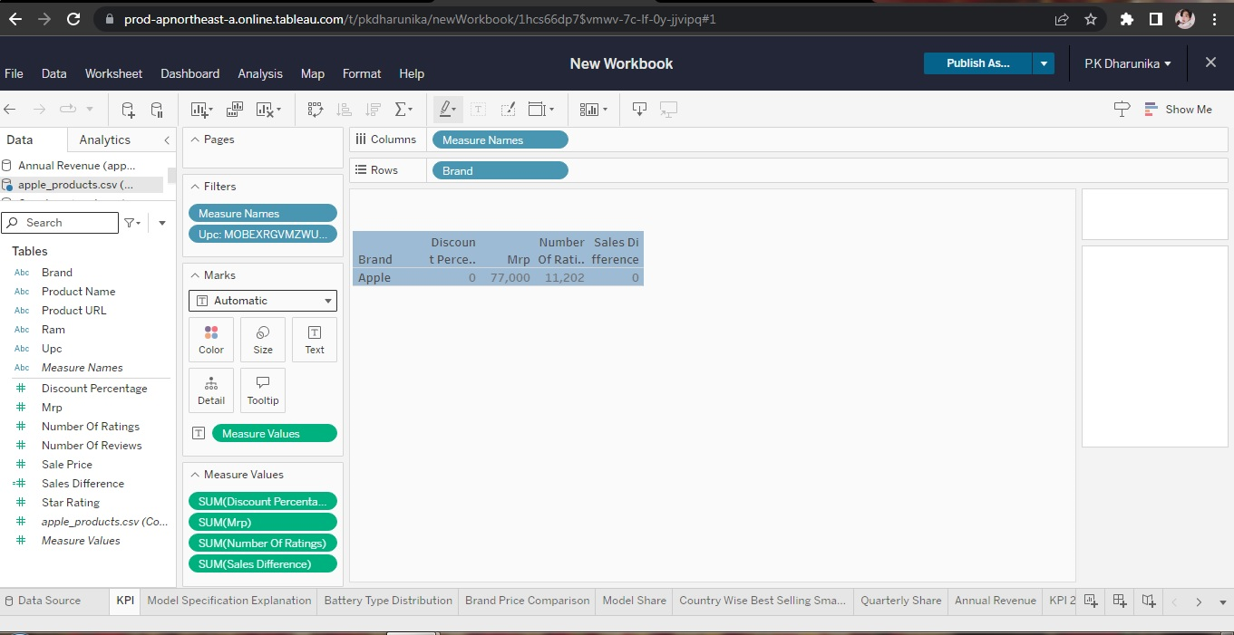

Model Specification Explanation
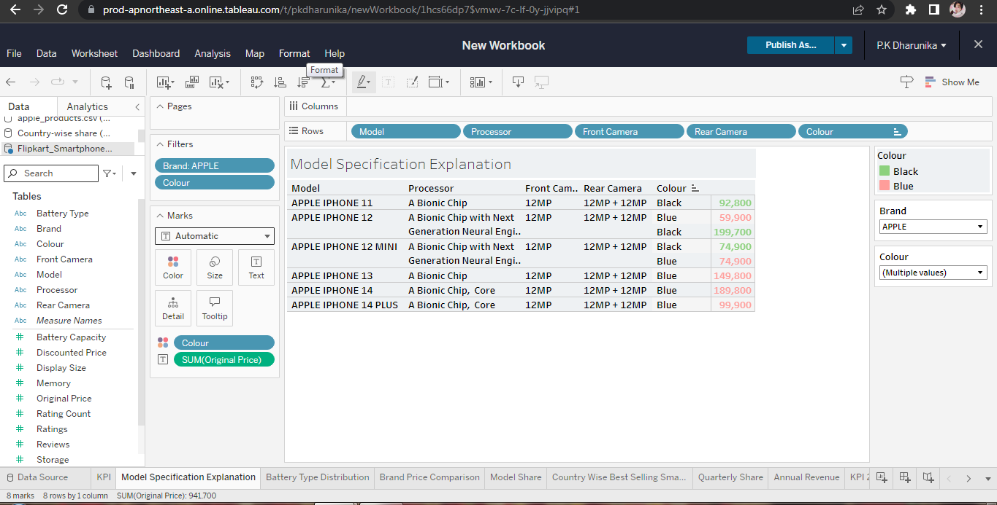

Battery Type
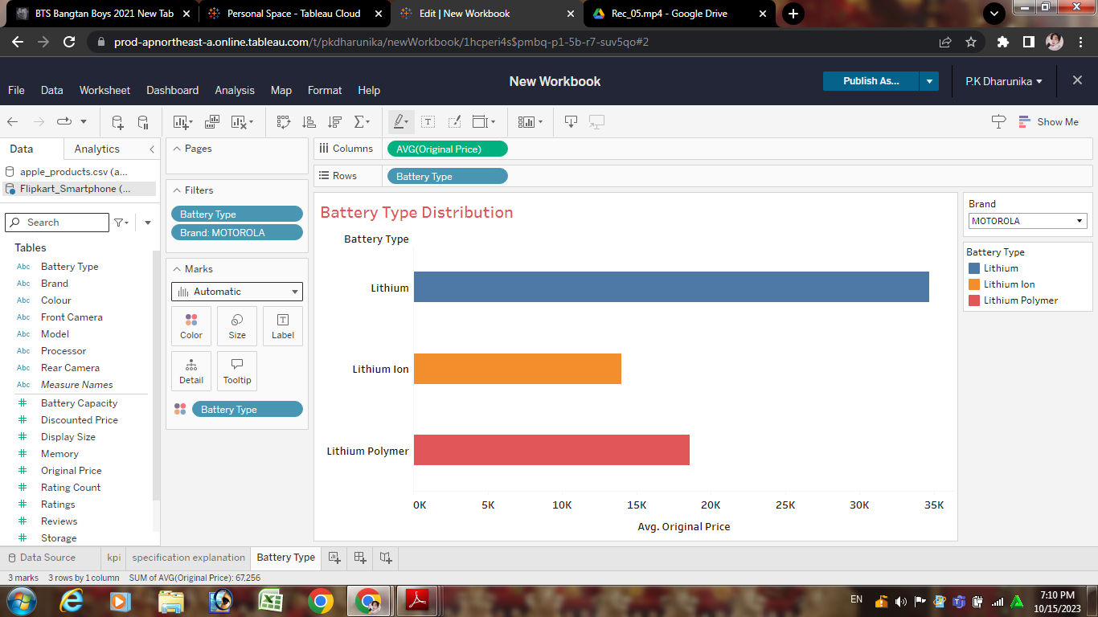

Brand Price Comparison
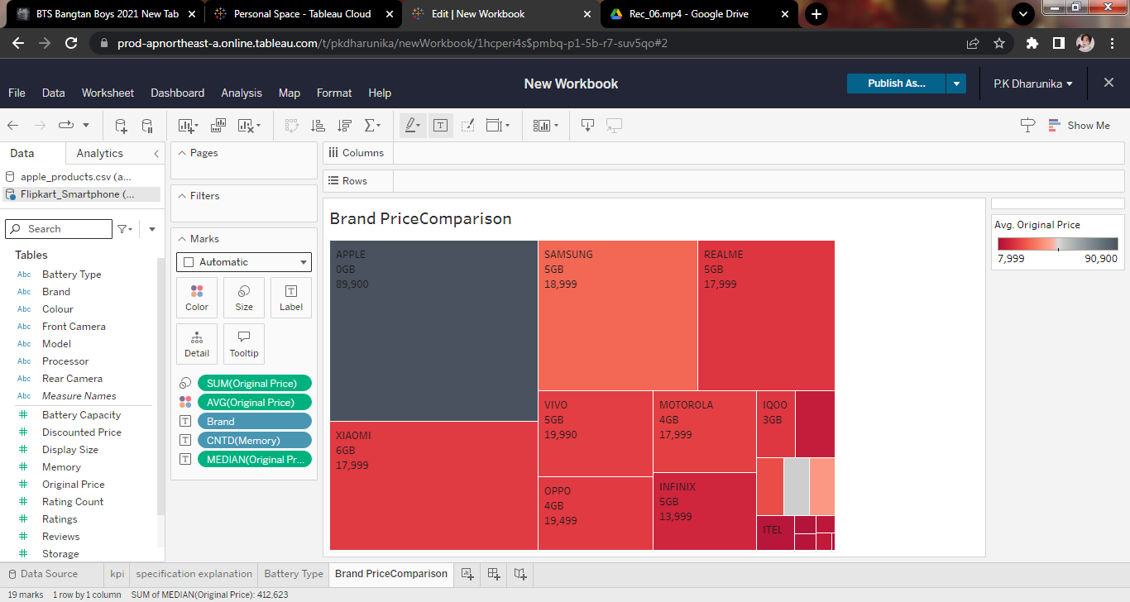

Model Share
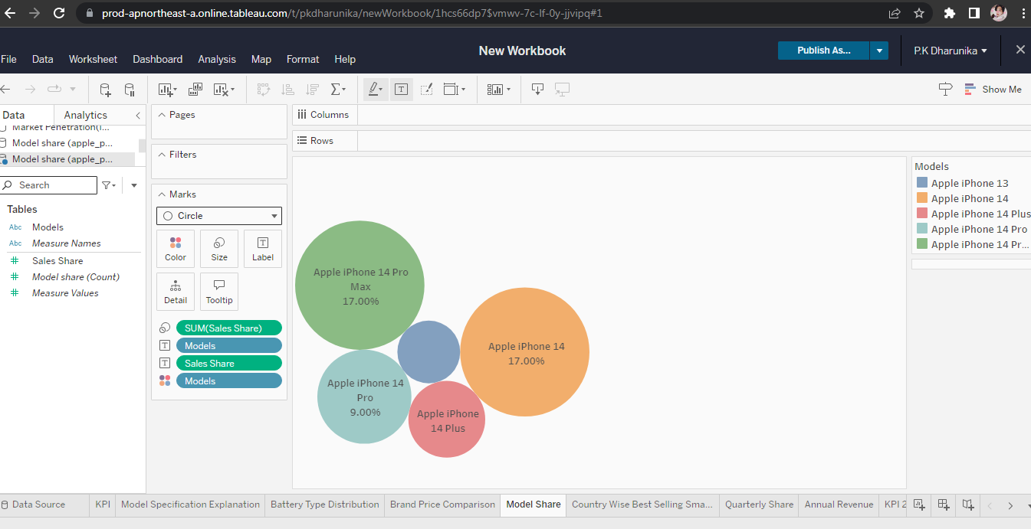

Country Wise Best Selling Smartphone
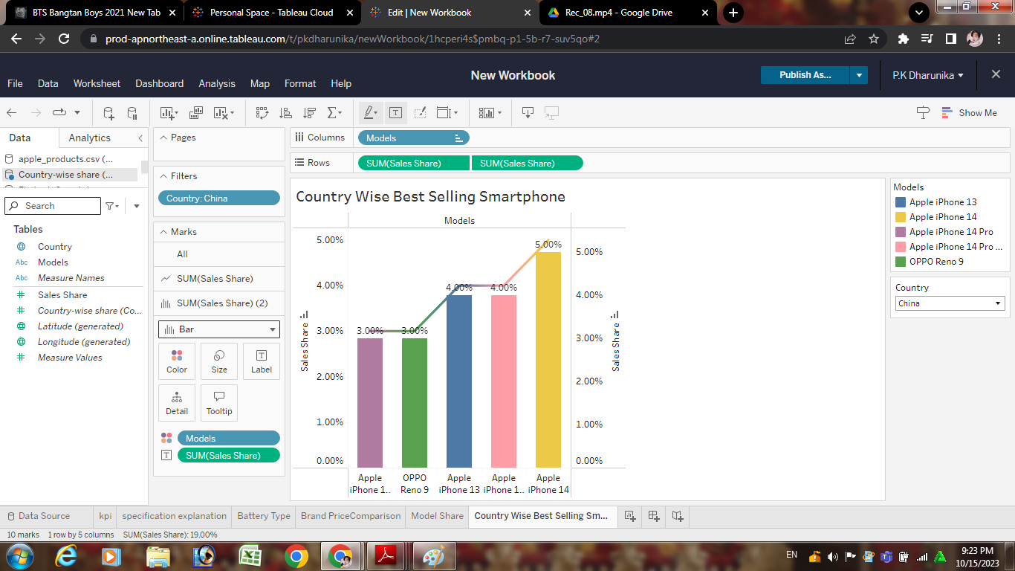

Quarterly Share
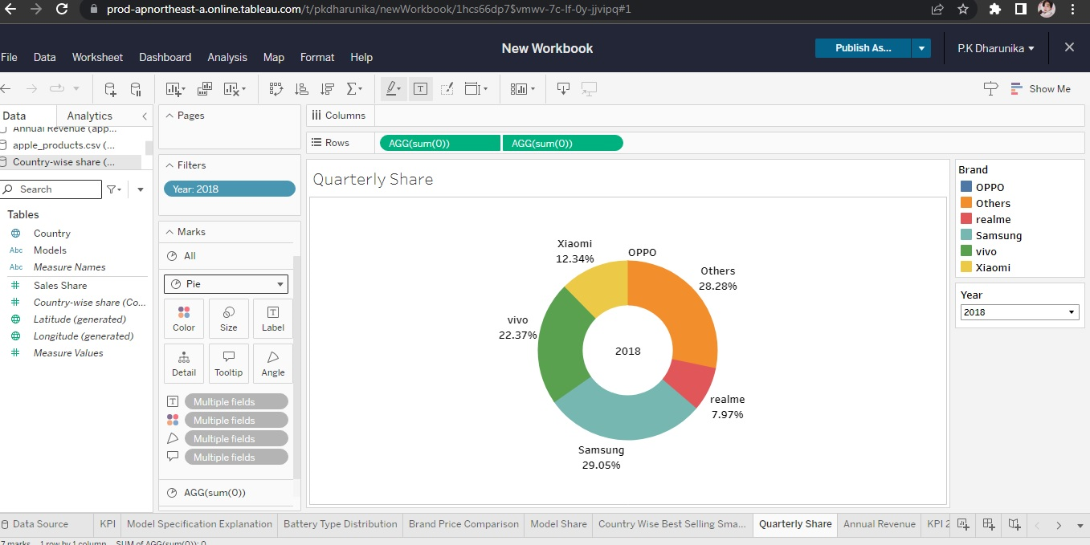

Annual Revenue
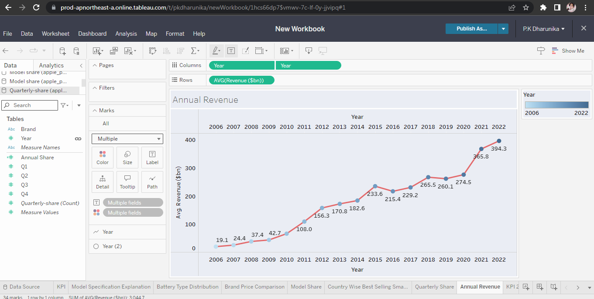

Table
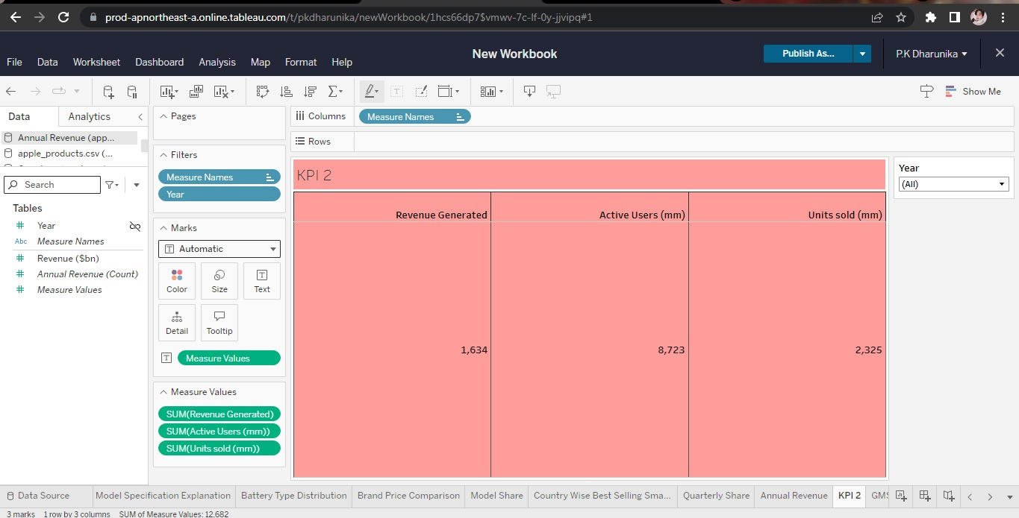

Global Map Share
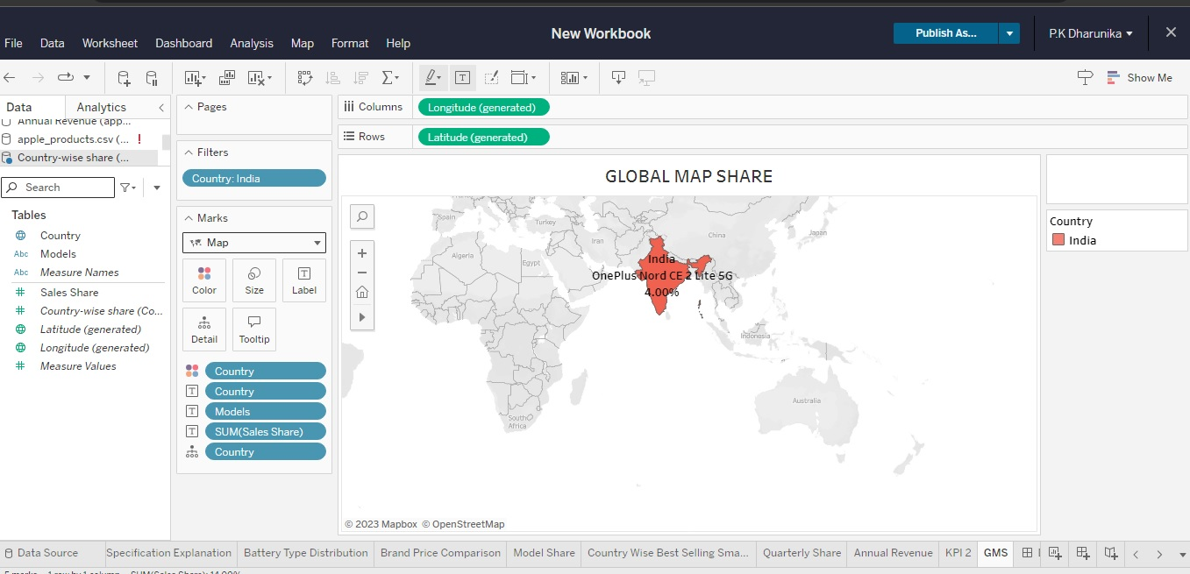

DashBoard 1
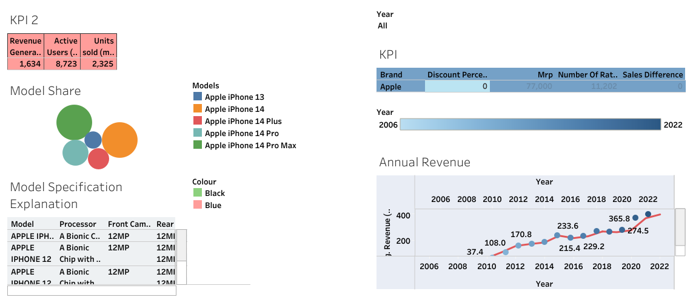

DashBoard 2

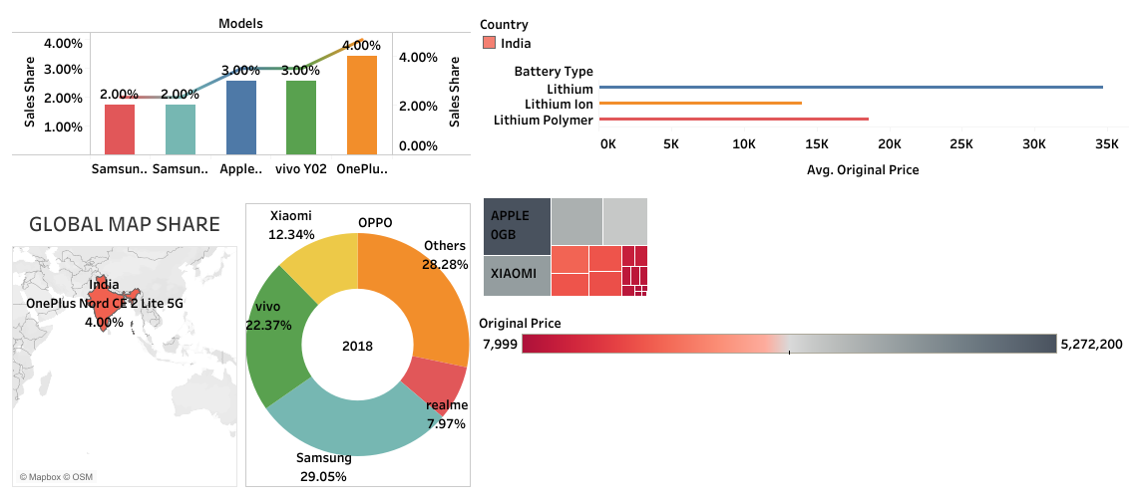

Story1
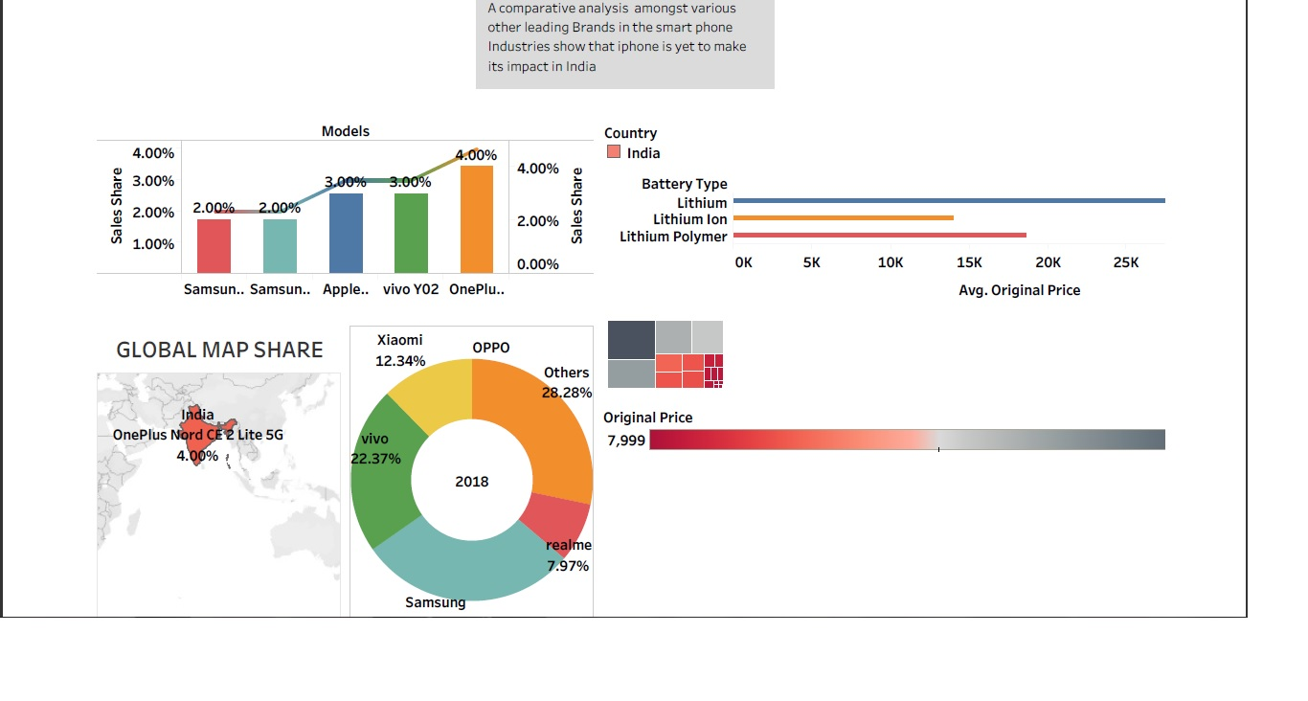
Tableau public link:
https://prod-apnortheast-a.online.tableau.com/t/pkdharunika/authoring/irevolutionadatadrivenexplorationofappleiphoneimpactinindia/KPI2#1
Conclusion
The iPhone, it’s that last part — the internet device — that has had the biggest effect on the world. That’s most obvious in this Ericsson chart showing the usage of mobile voice — relatively steady growth — and exploding mobile internet traffic — boosted by iOS and Android apps, photos and especially video — over the years. Apple has sold more than 1.2 billion iPhones and has become the most profitable public company in the world. Copycat phones from companies like Samsung, HTC, Motorola and Xiaomi proliferated across the globe, and now even people in places without steady electricity have smartphones.

